* [...](https://www.dfrobot.com/wiki/index.php/Line_Tracking_Sensor_for_Arduino_(SKU:SEN0017)" \o "Page tools)

Top of Form



Bottom of Form

Line Tracking Sensor for Arduino (SKU:SEN0017)

[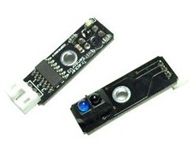](https://www.dfrobot.com/product-85.html)

[Line Tracking Sensor for Arduino (SKU:SEN0017)](https://www.dfrobot.com/product-85.html)

Contents

 [[hide](https://www.dfrobot.com/wiki/index.php/Line_Tracking_Sensor_for_Arduino_(SKU:SEN0017))]

* [1 Introduction](https://www.dfrobot.com/wiki/index.php/Line_Tracking_Sensor_for_Arduino_(SKU:SEN0017)#Introduction)
* [2 Features](https://www.dfrobot.com/wiki/index.php/Line_Tracking_Sensor_for_Arduino_(SKU:SEN0017)#Features)
* [3 Installation](https://www.dfrobot.com/wiki/index.php/Line_Tracking_Sensor_for_Arduino_(SKU:SEN0017)#Installation)
* [4 Connection Diagram](https://www.dfrobot.com/wiki/index.php/Line_Tracking_Sensor_for_Arduino_(SKU:SEN0017)#Connection_Diagram)
* [5 Sample Code](https://www.dfrobot.com/wiki/index.php/Line_Tracking_Sensor_for_Arduino_(SKU:SEN0017)#Sample_Code)

Introduction

The [DFRobot Line Tracking Sensor for Arduino](https://www.dfrobot.com/product-85.html) can detect the white lines in black and black lines in white. The single line-tracking signals can provide a stable output signals TTL, so look for more accurate and more stable line. Optional multi-channel mix is easy to install with the necessary line-tracking robot sensors.

Features

* Power supply: +5V
* Operating current: <10mA
* Operating temperature range: 0°C ~ + 50°C
* Output interface: 3-wire interface (1 - signal, 2 - power, 3 - power supply negative)
* Output Level: TTL level (black line of low effective, high efficient white line)
* Module Size: 10mm×35mm
* Module Weight: About 1g

Installation

The best distance between objects such as ground and the sensor is 1-2 cm.

Connection Diagram

[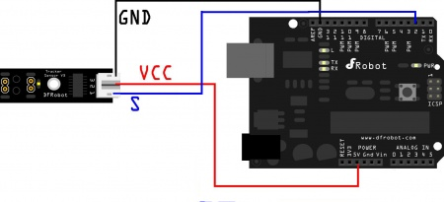](https://www.dfrobot.com/wiki/index.php/File:SEN0017connectionD.jpg)

Line Tracking Sensor connection

Sample Code

*///Arduino Sample Code*

void setup()

{

Serial.begin(9600);

}

void loop()

{

Serial.println(digitalRead(2)); *// print the data from the sensor*

delay(500);

}